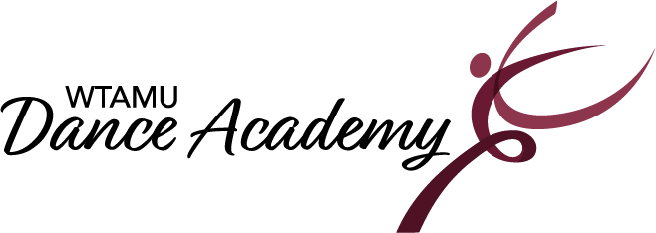

2023-2024 Class Schedule

Studio 154 | Monday | Tuesday | Wednesday | Thursday
4:00-5:00 pm  Teacher: | Ballet/Jazz  (6-8 yrs.)  Kaleigh | Ballet/Tap  (3-5 yrs.)  Lorelai | Ballet/Tap  (3-5 yrs.)  Ally | Musical Theatre  Tap  (6-8 yrs.)  Lorelai
5:00-6:00 pm  Teacher: | Ballet/Jazz  (9-12 yrs.)  Kaleigh | Tap  (9-12 yrs.)  Kaleigh | Hip Hop  (9-12 yrs.)  Amon | Musical Theatre Dance  (9-12 yrs.)  Amon

In Person- Registration will take place at the Dance Studio in Room 154. We are located in Mary Moody Northen Hall on the WT Campus.
August 5th from 9:00-12:00.
August 12th from 1:00-3:00.
August 19th from 9:00-12:00.
Classes Begin: August 21st, 2023.
For questions, please contact the Dance Academy office at 806-651-2820 or danceacademy@wtamu.edu. The academy office is open when classes are in session. The office is adjacent to Studio 154.
23-24 Class Descriptions
All classes are 1 hour in length and held in Dance Studio 154 located in Mary Moody Northen Hall on the West Texas A&M University campus.

Ballet/Tap 3-5yrs. -This popular combo class consists of fun, nurturing, engaging, movement exercises using basic steps to introduce dance terminology, all while encouraging creativity and group interaction. Two routines will be taught and presented in the Academy’s annual recital in May.

Ballet/Jazz 6-8yrs. – This exciting combo class will focus on the fundamentals of ballet and jazz with more coordination and sequence-related technique exercises implemented at the appropriate level. Two routines will be taught and presented in the Academy’s annual recital in May.

Musical Theatre Tap 6-8yrs.- Embrace your inner Broadway star in this combo class while developing skills also in Tap Dance! Exercises that develop coordination and rhythm while improving timing and agility are the focus of this class. Two routines will be taught and presented in the Academy’s annual recital in May.

Ballet/Jazz 9-12yrs. –Ballet is the foundation of all dance forms. This class will focus on terminology and classical technique in which develop coordination, strength, balance, proper alignment, and flexibility and an excellent experience for the dancer who is interested in further strengthening their jazz dance technique as well as develop a solid technical base and perform innovative choreography. Two routines will be taught and presented in the Academy’s annual recital in May.

Tap 9-12yrs. –Tap is a popular genre of American theatrical dance distinguished by percussive footwork. Dancers develop a sense of rhythm and musicality and perform progressions to increase technical skills. One routine will be taught and presented in the Academy’s annual recital in May.

Musical Theatre Dance 9-12yrs. –is a jazz-based class filled with Broadway style dancing and music. This high-energy class incorporates and explores presentational elements as well as learn one routine to be taught and presented in the Academy’s annual recital in May.

Hip Hop Dance 9-12yrs.- This class is a fun, energetic and expressive dance genre using the latest dance moves set to age-appropriate hip hop music. One routine will be taught and presented in the Academy’s annual recital in May.

